Creating a Safe Haven: How Amko Fence Company Keeps Your Family Secure

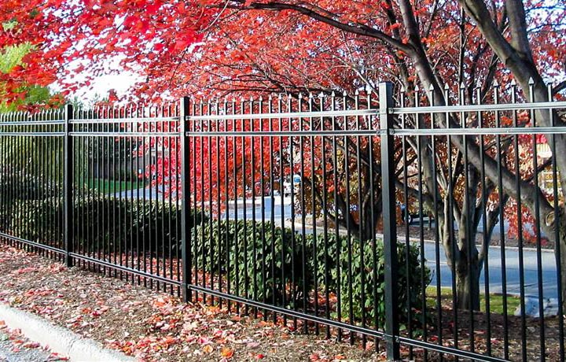

When it comes to choosing a fence for your home, ensuring that both safety and aesthetics are prioritized is crucial. For homeowners who seek both high-quality craftsmanship and unmatched reliability, **Amko Fence Company** stands out as the ultimate choice. Offering a blend of **exceptional service**, **top-notch materials**, and a commitment to customer satisfaction, Amko Fence Company has earned a reputation for transforming residential properties into secure and stylish havens. This article will delve into why Amko Fence Company is the ideal solution for homeowners looking to enhance their properties with reliable, durable, and visually appealing fencing.

**Unmatched Quality and Durability of Amko Fences**

One of the primary reasons why homeowners choose Amko Fence Company is their **commitment to top-tier quality**. When you invest in a fence for your home, you want something that lasts for years while standing up to the elements. Amko Fence Company uses only the highest quality materials that are designed to endure harsh weather conditions, from blistering heat to heavy rain and snow.

Their wide range of materials, including **vinyl**, **wood**, **aluminum**, **chain link**, and **steel**, offers long-lasting durability, ensuring that your fence remains intact and performs well over time. Whether you're looking for something that requires minimal maintenance, such as **vinyl fencing**, or something that provides additional security, such as **steel fences**, Amko has the perfect solution for your needs.

Additionally, Amko Fence Company’s fences are engineered with **precision** and **expert craftsmanship**, ensuring that every installation is performed with the utmost attention to detail. This means that your fence won't just be durable; it will also be **structurally sound** and resilient against potential wear and tear.

**Aesthetic Appeal and Customization Options**

Beyond functionality, the **aesthetic appeal** of a fence plays a vital role in enhancing the curb appeal of your home. Amko Fence Company understands that each property is unique, and they provide a **wide range of customizable options** to match your home’s style. Whether you're looking for a traditional wooden fence to complement a rustic design or a sleek, modern aluminum fence to fit a contemporary aesthetic, Amko offers the perfect match.

Their customization options are not limited to materials alone; homeowners can also select from an array of **finishes, colors**, and **designs**. This ensures that your fence not only serves its intended purpose but also enhances the overall visual appeal of your property. Amko’s team of designers works with you closely to ensure that the finished product aligns perfectly with your vision.

Moreover, Amko offers **specialty options** like **decorative gates** and **ornamental accents** that add a touch of elegance to your fencing. Whether you’re aiming for a minimalist look or something more ornate, their extensive selection provides endless possibilities to enhance your property’s aesthetic charm.

**Comprehensive Range of Fencing Solutions**

Amko Fence Company prides itself on offering a **diverse selection of fencing solutions** to meet the varying needs of homeowners. They cater to a wide range of requirements, whether you're looking for **privacy**, **security**, or **aesthetic appeal**. Below is a breakdown of some of the most popular fencing options available from Amko:

1. **Privacy Fencing**: If you’re looking to create a private retreat in your backyard, Amko’s **privacy fences** are a perfect choice. Made from materials like **wood** and **vinyl**, these fences provide the ultimate level of seclusion, shielding your property from prying eyes while creating a safe and serene environment.
2. **Security Fencing**: For homeowners seeking to increase their security, **chain-link fences**, **steel fences**, and **wrought iron fences** provide optimal protection without compromising on durability. These options are ideal for keeping intruders out while offering a high level of visibility around the perimeter of your home.
3. **Decorative Fencing**: For those who wish to add an elegant touch to their property, **decorative fences** such as **aluminum** or **wrought iron** offer both beauty and functionality. These fences provide a sturdy barrier while contributing to the aesthetic appeal of your home.
4. **Pool Fencing**: For families with children and pets, safety is a primary concern. Amko’s **pool fences** are designed to provide a secure barrier around your pool area while ensuring that it’s easy to maintain. These fences are available in a variety of materials, including **aluminum** and **glass**, to suit your design preferences.
5. **Farm and Agricultural Fencing**: Amko also specializes in **farm fencing** that offers durable solutions for agricultural properties. Whether you’re keeping livestock safe or sectioning off land, Amko’s fencing solutions are robust and designed to withstand the rigors of rural environments.

**Professional Installation and Expert Craftsmanship**

While selecting the right materials and design for your fence is crucial, professional installation is equally important. Amko Fence Company provides **expert installation services** that ensure your fence is installed correctly and securely. Their team of experienced installers is well-versed in handling a variety of fence types and understands the nuances of each material.

Amko’s commitment to excellence means that each installation is handled with precision and care, minimizing the risk of errors and ensuring that your fence is both functional and aesthetically pleasing. Furthermore, their team works diligently to complete installations in a timely manner, respecting your property and minimizing any disruption to your daily life.

**Affordable Pricing Without Compromising on Quality**

Another reason homeowners turn to Amko Fence Company is their commitment to providing **affordable fencing solutions**. While offering top-quality materials and expert installation, Amko strives to keep their prices competitive. They understand the importance of getting the best value for your money and work hard to ensure that each project is completed within budget.

In addition to offering **affordable pricing**, Amko Fence Company provides flexible payment options to make the investment more manageable. Their transparent pricing structure ensures that there are no hidden costs, giving homeowners peace of mind knowing they won’t be surprised by additional fees.

**Exceptional Customer Service and Satisfaction Guarantee**

At Amko Fence Company, customer satisfaction is a top priority. From the initial consultation to post-installation support, their team is dedicated to providing an **exceptional customer experience**. They work closely with clients to understand their specific needs, preferences, and budget, ensuring that the final product meets or exceeds expectations.

Amko offers a **satisfaction guarantee** on all installations, meaning that if you’re not completely satisfied with your fence, they will work to resolve any issues. Their commitment to quality and customer service has earned them a reputation as one of the most trusted fence companies in the industry.

**Conclusion: Choose Amko Fence Company for Unmatched Safety and Style**

When it comes to fencing solutions, **Amko Fence Company** stands out as the ultimate choice for homeowners who want the perfect blend of **safety, style**, and **durability**. With a wide variety of materials, design options, and professional installation services, Amko ensures that every fence they install enhances the beauty and security of your home.

Their commitment to quality craftsmanship, affordable pricing, and customer satisfaction makes them the go-to choice for homeowners looking to invest in a fence that will last for years. Whether you’re looking to enhance your privacy, increase security, or simply elevate your home’s curb appeal, Amko Fence Company provides the perfect fencing solution to meet your needs.

For the ultimate in fencing quality, style, and customer satisfaction, **Amko Fence Company** is the clear choice for your home’s safety and aesthetic needs.